Agenda Item:
Publication status: | Open  Confidential | ✓

Executive Summary

Meeting | Environment & Sustainability Advisory Group. |  |  |  | ✓ | Date | .23
Report title | Carbon Reporting – Future Net Zero Accreditation – 2018 to 2022.
Author | Sue Lockett, Director of Facilities
Action | DECISION |  | n/a | INFORMATION |  |  |  | Yes
Key points | - Overview of STCG Climate and Sustainability Strategy  - Update on STCG Roadmap to Net Zero  - EV Charging Policy (DRAFT) for comment
Recommendations | - This report is provided for discussion and noting by the Group.
Link to strategic objective:
- 7. Progress STCG climate change response plan, working to achieve ‘emerging’ status within the AoC Roadmap to Sustainability Framework and influencing the Group’s new Estates Strategy.

Financial |  | Expected Reduction in overhead costs and focusing investment on strategic priorities and invest to save projects.
Legal/Statutory/Compliance/Governance |  | Statutory Reporting Requirement.
Reputational |  | Possible reputational damage in the event of failure to control and report consumption, costs and Carbon Footprint. Reporting in is in the public domain.
Related Risk Areas |  | Financial & Reputational.

      - STCG Climate and Sustainability Strategy Overview:
As per previous reports the baseline was set using 18/19 data (pre-pandemic). It is worth noting and recording STCGs key achievements to date:
    - Agreed baseline Carbon Footprint data (year 18/19)
    - Published Climate Change Commitment Statement (Feb 23)
    - Signed up to “Race to Net Zero” (Feb 23)
    - Developed Roadmap to Sustainability aligning with FE Climate Action Road Map (2022)
    - Achieved Emerging (June 2023) – independent audit to verify being identified
    - Updated Roadmap to align with AoCs Green College Commitment and UN SDGs
    - Develop plan for “Established”- in development (June 2023)

Further details on achievements are broken down as part of the “Emerging” status in the Roadmap.

2. Climate Action Roadmap:
The Climate Commission for UK Higher and Further Education was established in November 2019. Its goal is to develop a strategic, sector-wide approach to tackle the climate emergency. The Commission went on to develop a ‘road map’ for further education colleges to reach the net zero target. The College adopted the Climate Action Roadmap as a framework to drive this strategy. The roadmap includes three ‘levels’ to approach sustainability, organised by different levels of maturity:

• Emerging: colleges just beginning to address sustainability
• Established: colleges with an established approach to sustainability and structures in place to support it
• Leading: colleges which are models to others on sustainability.

Now that STCG have reached Emerging status, the focus in the next 2 years is to reach “Established”. This will need to be mapped out with as part of an Action Plan with the Environment & Sustainability Advisory Group.

3. As part of the STCG road to net zero, one of the main ways to achieve this is to measure greenhouse gas emissions. Therefore, STCG along with many organisations across the globe will align to the widely used Greenhouse Gas Protocol (GHG Protocol) which provides standards and guidance to measure, manage and report greenhouse gas emissions from their operations and value chains. As part of this standard protocol GHG is divided into three categories called “scopes”, known as Scope Emissions. The Scope of each area is broken down below.

Scope 1: Direct Emissions ie owned or controlled | Scope 2: Energy Direct Emissions | Scope 3: Other Indirect Emissions in value chain
- - all vehicles owned or controlled by college (Electric vehicles fall into scope 2)  - - refrigeration, cooling consumed/leak/top ups from air conditioning units, etc.);  - - natural gas consumption | - Purchased Electricity for own use | - Purchased goods & services  - Capital goods  - Fuel & energy – related activities not included in Scope 1 or Scope 2  - Upstream Transportation and Distribution  - Waste from operations  - Business travel  - Employee commuting  - Upstream Leased assets  - Downstream Transportation and Distribution  - Processing of Sold Products  - Use of sold products  - End-of-Life Treatment of Sold Products  - Downstream Leased Assets  - Franchises  - Investments
*Scope 1, 2 & 3 explained
*Development of Scope 3 is part of achieving Established

STCG are currently measuring and reporting on Scope 1, 2 with exception of refrigeration top up for air con, this is being collated and will be measured from 1st Jan 2023 going forward.

Scope 3 Business Travel is also being measured but only for employee mileage claims, not for events etc..

Below is a graph that this an overview of our current footprint trend to date, full report will be completed at end of year.
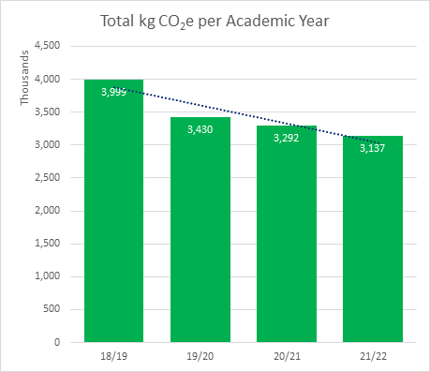

4. The STCG has invested in Electricity Vehicle (EV) charging points across the estate. To enable for these to be managed effectively an EV Charging Policy has been drafted (attached) for your comment

5. The colleges has put a bid in April for £77k funding through Salix as part of Government initiative to support colleges in planning their reduction to carbon. Decision on funding will be revealed on 7th July 2023.

